**C64 Cart64Out Rev. 0**

**Testing**

The tests were conducted with three different motherboards (250407 and 250469 Rev. 4 and Rev B.) and several cartridges:

* Versa64Cart Rev. 1.1 and Rev. 1 with different software
* Final Cartridge III+
* Extern Kernal 8 (REX Datentechnik 9628)
* Dela DOS
* Handic FORTH 64
* Ultimate II+

All jumpers installed. All cartridges work flawlessly with the Cart64Out connected

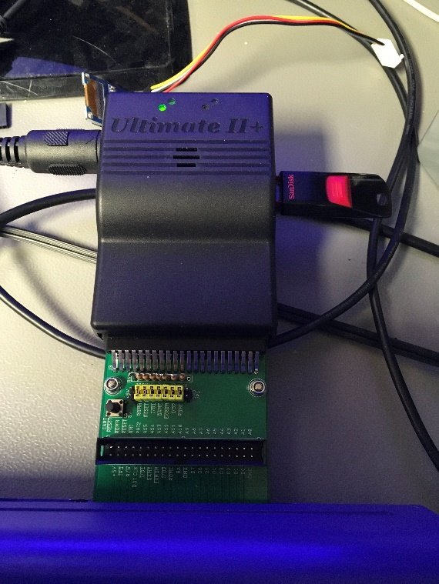

Figure 1: Test with Ultimate II+

The reset-switch resets the system.

While inserted into the C64, J2 can be accessed and the labeling on both sides of the connector can be read.

Cart64Out is fully functional.